# Hazelcat Management Center

1. 下载安装包

*wget <https://download.hazelcast.com/management-center/hazelcast-management-center-3.10.zip>*

1. 解压并安装

*tar -zxvf hazelcast-management-center-3.10.zip*

*cd hazelcast-management-center-3.10.1*

*java -jar hazelcast-mancenter-3.10.1.war 8080 hazelcast-mancenter*

1. 打开页面

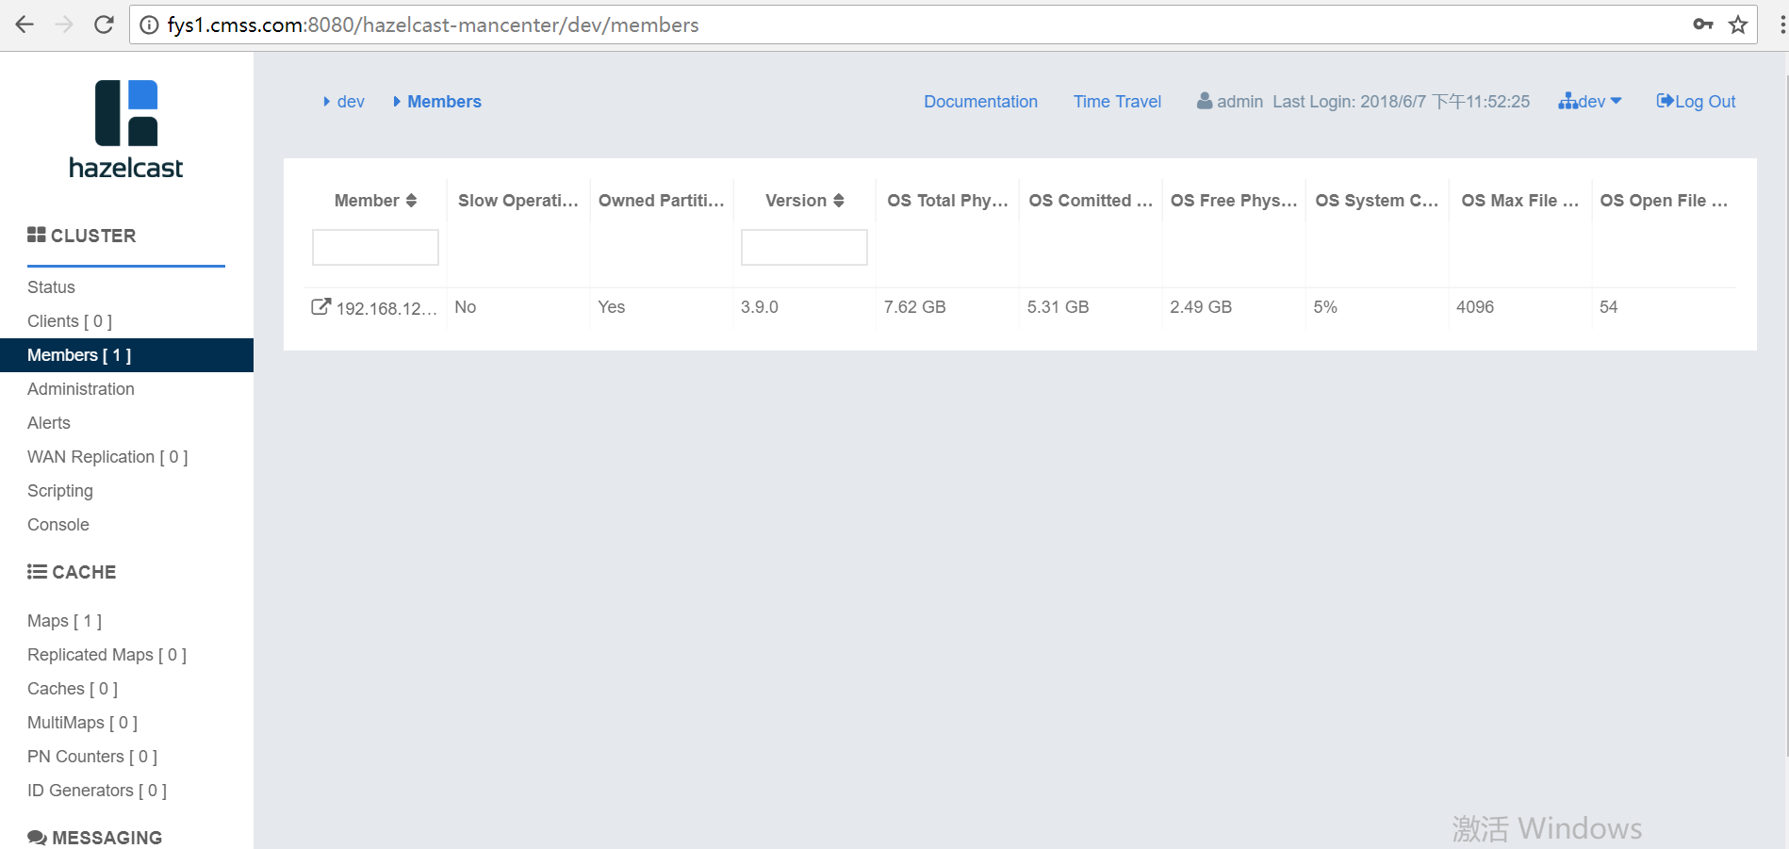

1. 将hazelcast member注册到mancenter中，在启动时添加配置：

*Config config = new Config();*

*config.getManagementCenterConfig().setEnabled(true); config.getManagementCenterConfig().setUrl("http://10.139.4.98:8080/hazelcast-mancenter");*

*HazelcastInstance instance = Hazelcast.newHazelcastInstance(config);*

1. 方法2：

在hazelcast.xml中配置：

*<management-center enabled="true">*

*https://localhost:sslPortNumber/hazelcast-mancenter</management-center>*